Curriculum Vitae of M. Habeeb
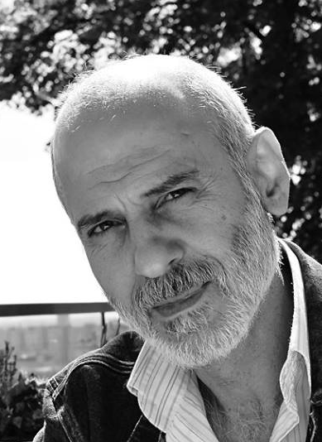

Name: Mohammad Habeeb
Address: Asalkroken 3, 4025 Stavanger
Mobile: +4746714365
E-mail: 42habebhabeeb@gmail.com
Born: 19/03/1961
Marital status: Married, two children
LinkedIn: https://www.linkedin.com/in/mohammad-habeeb-7174a183/

Education
- Bachelor of Arts, English Department, Tishreen University in Lattakia, Syria
- .
Professional Experience
- Over 20 years of experience in fiction and nonfiction translation and interpretation English-Arabic and Norwegian-Arabic
- Writing poetry and short stories
Work Experience
- In Norway

2021-2022 Assistant teacher at Gausel school, Stavanger
2018- 2019 A cultural mediator at Sølvberget, Stavanger’s cultural center, a scholarship from the ministry of culture
2018-2019 Teacher of Social Studies in Arabic at Johannes Lærningssenter
2018 Librarian training at Sølvberget
2016-2017 Assistant teacher Arabic-Norwegian at Johannes Lærningssenter
2. In Syria
1986- 2015 Teacher of English at preparatory and high school, in Lattakia, Syria
2003-2011 Volunteer at the Autism Association in Lattakia, Syria, as an advisor, and manager of activities
Translator
2014-2018 Freelance translator with KIKA magazine, UK, London
2008-2017 Freelance translator with Reprieve, a Charity in UK, London. Translating official reports and documents
Since 2016 Member of NorskPen
Since 2009 Member of the Arab Syrian Writers Union, Society Of Translation

Languages
Arabic - Mother tongue
English - Fluent in writing and speaking
Norwegian - Good writing and speaking

Translated works meanwhile living in Syria
- Fictions: Novels:

Title | Author | Publishing house

al-Mada, Syria 2002 | José Saramago | Blindness
Alsaki, Beirut 2012 | Simon Scarrow | The gladiator
(Dal), Syria 2015 | Khaled Alhusaini | The Mountains Echoed,
(Dal), Syria 2015 | James Killman | - How Late It Was
Alhewar ,Syria 2015 | Robert Minhinink | Keys for Babylon…
(Dal), Syria 2016 | by Moris Farhy | A Designated Man
Ward, Syria, under publishing | by Angela Carter | Nights At The Circus
Ward, Syria, under publishing | GM Qiutzy . | Elizabeth Costello
Drama
Title | Author | Publishing house

Mada, Syria 2001 | T.S Eliot | The Family Reunion

Short stories
  Title | Author | Publishing house

Alia Mundi 2019 | Ana Stjelja | Aisha in the Dream Land
Horan, Syria 2001 | James Kelman | The End of Beginning
Ministry of Education Syria1996 | Sindwi Magona | Spohhia
Looking for a publisher | Different authors | Moral short stories

Nonfiction: Pschology
  Title | Author | Publishing house

Alhewar, Sryia,2012 | Erich Fromm | the pathology of Normalcy, contribution to the science of Man
Alhewar, Sryia,2013 | Erich Fromm | On Being Human
Alhewar, Sryia,2014 | Carl Gostaf Yong | Development of personality

Literary criticism
  Title | Author | Publishing house

Alhewar, Sryia,2014 | Terry Egilton | Mythes of Power

Studies
  Title | Author | Publishing house
  The Hinge Factor, (Role of Chance and Stupidity in Changing the Course of History) | Erick Durtchmid | Al-Mada, Syria 2002
  From medication to Templation | Osho | Al-Khayal, Beirut 2006
  The Macrobiotics | Edward Sisco | Al-Khayal, Beirut 2004
  The Transformational Breathing | Judith Crafts | Al-Khayal, Beirut 2009
  The Children of Jihad | Jared Cohen | Al-Khayal, Beirut 2009
  Reforming the Repressive state apparatus | A group of authors | Eskandaron, syria 2011

Meanwhile living in Norway

Title | Author | Publishing house

Dal, Syria,01.10. 2019 | Jon Fosse Norsk | Det er Alis
Sard 2021 | Roy Jacobsen Norsk | De Usynlige
Sard ? | Roy Jacobsen Norsk | Hvit Hav

Almasrah Alalami, Kuwait, november 2021 | Jon Fosse Norsk | De Døde Hundane  The Dead Dogs
Almasrah Alalami, 2023 | Jon Fosse Norsk | Jeg er vinden  I am the WInd
Almasrah Alalami, 2023 | Jon Fosse Norsk | Draum om hausten  A Dream of autumn
Almasrah Alalami, 2023 | Jon Fosse Norsk | Noko Kjem til Å Komme  Somebody is coming
Almasrah Alalami, ? | Olaug Nelssin Norsk | Ikkje Tenk På Det  Don’t think about it
Almasrah Alalami, ? | Maria Tryti Vennerød Norsk | Dama i Luka  receptionidt
Almasrah Alalami, ? | Maria Tryti Vennerød Norsk | Ren Natur  Pure Nature
Sølvberget, Stavanger 2019 | Alexander Kielland Norsk | Karen  Karen

