Nobuyoshi Mori
Books written or translated by me alone:
Textbook on German grammar: Praktische Deutsche Grammatik für Anfänger, Daigakusyorin, 1993.

Norwegian grammar, Daigakusyorin, 1990. (red and blue one)
1500 basic Norwegian words: Daigakusyorin, 1990. (blue one)
1500 basic Icelandic words: Daigakusyorin, 1996. (green one)
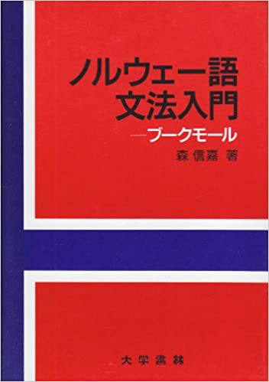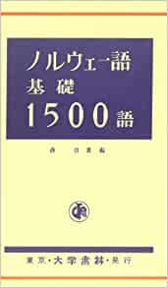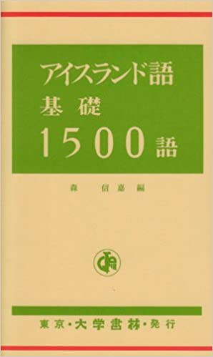

Sandinavian languages for kids: Kita Yooroppa no moji to kotba, Komine Shoten, 2005.

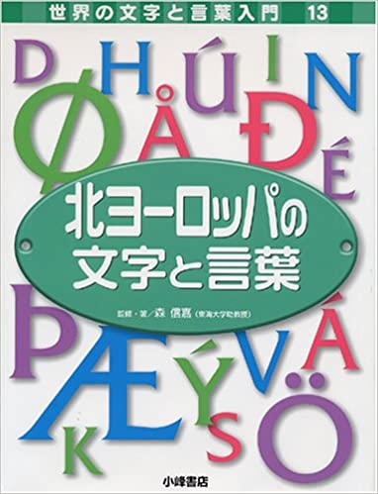

Scandinavian countries for kids: Sekai no Kuniguni – Denmark, Norway, Sweden,
Asunaro Shobo, 2014
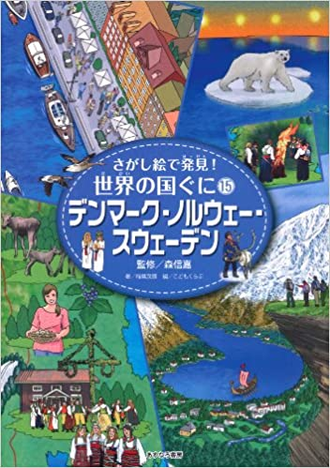

Skald sagas (Kormáks saga / Hallfreðar saga) (Tanslated from old Norwegian: Sukkarudo Shijin no Saga, Tokai Univ Press, 2005.

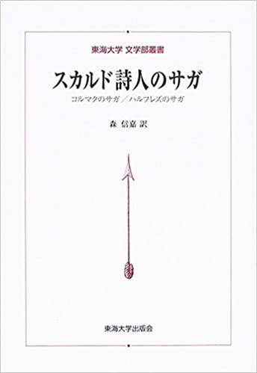r

Theater manuscript on Edvard Munch, 2013.
http://www.naruko.gr.jp/news/uploads/251214-munku-kouen.pdf)

Lecture on «Draumkvæde» from Telemark which I translated orally in a lecture held at the conference directed by The Society for Icelandic Studies of Japan, 2019.
http://www.icelandicstudies.jp/en/profile/

Translation (together with other articles translated by other translators):

Selected poems by Jan Erik Vold, Paal Brekke, Lars Saabye Christensen, Tor Ulven, Tone Hødnebø, in the poetry journal «Gendaishi Techo», Gendai Sjichosha, 2013.
http://www.shichosha.co.jp/gendaishitecho/item_860.html
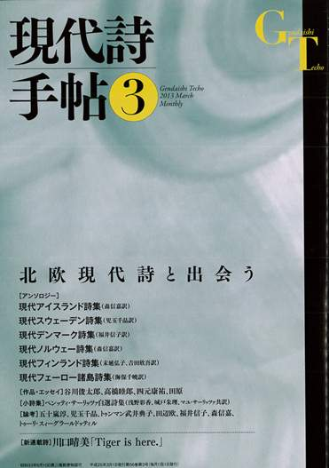

Articles on Nordic languages: Norwegian / icelandic / Faroese, in Hokuo no kotoba, Tokai Univ. Press, 2001.
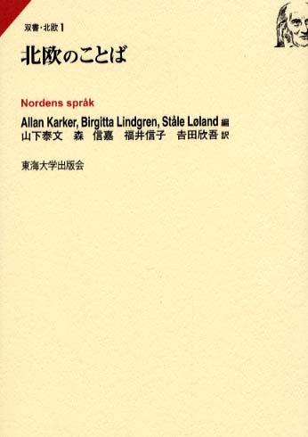

Article : Sang for Norge from Digt og Sange, in «Hokuo-sekai no kotoba to bunka», Seibundo, 2007.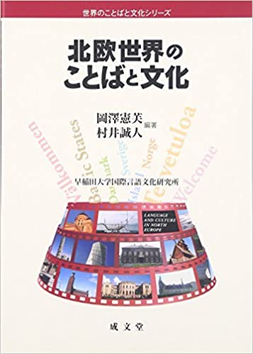

Articles and essays on Nordic languages & mythology (together with other articles written by other authors):
Articles on Nordic languages, in «Hokuo ga mietekuru», Saimaru Shuppankai, 1997.

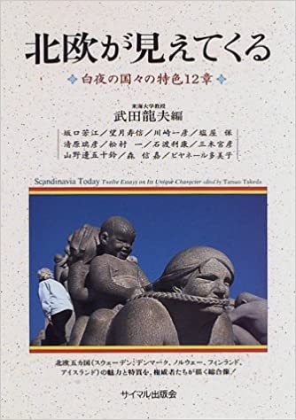

Articles on Norwegian dictionaries, in «Sekai no kotoba – Jisho no jisho (Ordbok om ordbøker)», Sanseido, 2008.

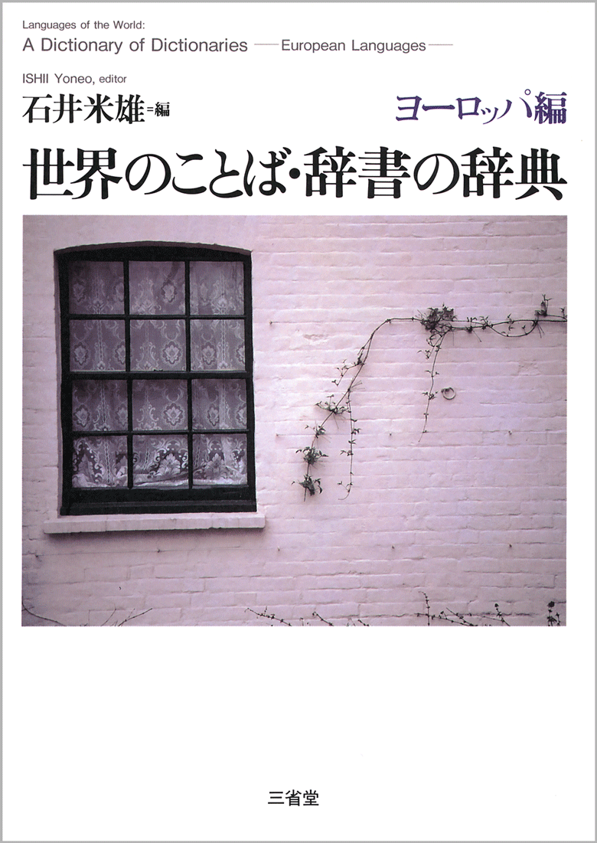

Articles on expressions and greetings of Norwegian, in «Sekai no kotoba – Deai no hyogen jiten (Dictionary on expressions and greetings», Sanseido, 2004.
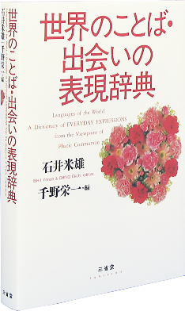

100 Norwegian words out o 31 world languages, i «Sekai no kotoba – 100 go jiten», (Dictionary on 100 words of the world), Sanseido, 1999.
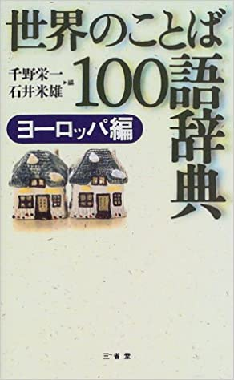

On old Norwegian features in Norwegian dialects, i «Aisurando no gengo, shinwa, rekishi» (Icelandic language, mythology and history), Aso Shuppan, 2011.

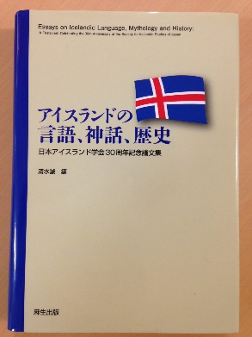

Artticles on Nordic mythology, North Germanic languages in «Hokuogaku no susume» (Introduction to Nodic Studies), Tokai Univ. Press, 2010 .

