Erik Sveberg Dietrichs:

Life on the Edge

How the body copes with extreme natural conditions

-

A popular science book about surviving in extreme conditions

Background

Erik Sveberg Dietrichs (born 1985) is a medical doctor and a scholar. He finished his PhD in 2015. His thesis was about the effects of low temperatures on the body, and how to safely rewarm victims of accidental hypothermia. Dietrichs has written numerous academic and popular science articles about medicine and history, and regularly gives academic and more generalist lectures. Sharing knowledge in an accessible manner is his passion.

Life on the Edge is about how people survive in the harshest conditions. For many, the book will provide an interesting and useful introduction to medicine and the ways in which our bodies adapt to our surroundings. The facts are presented with illustrations and stories of people who have survived in terrible conditions. We also visit different groups of people who have learned to live in very difficult places. Thus it not only offers the reader useful information, but also provides an exciting and interesting context for the facts. The author’s intention is that the book and subject matter should be comparable with Giulia Enders’ Gut: The inside story of our body’s most underrated organ and Erika Fatland’s Sovietistan. This popular science book is kind of a travelogue in medical science and social anthropology, which will give the reader a greater understanding of humankind’s ability to live in the harshest places in the world.

The book

Human beings have an average body temperature of 37°C. Both plus and minus changes in temperature quickly affect the functioning of vital organs such as the heart and brain. In order to maintain a stable core temperature without any great effort, most of the world’s population live in temperate climes, where insulation and sufficient energy from food can keep them warm through the winter months. It is equally important that the place where we live allows us to avoid overheating in summer. People are also dependent on supplying the brain and other organs with sufficient amounts of oxygen. Oxygen density is greatest at sea level. If you then ascend several thousand metres, the oxygen density is lower and it therefore becomes harder to saturate the red blood cells with oxygen. The climate is often more extreme at higher altitudes as well, so the majority of people live in low-lying areas. Furthermore, most people have traditionally sustained themselves by harvesting the land, or fishing in rivers or the sea. Gathering food underwater is challenging, as we do not have gills and so cannot make use of the oxygen found in water, which covers 70% of the planet.

This would indicate that the human body is best suited to live in temperate climes and at sea level. However, not all people live in such places. As a result of humankind’s ability to adapt and exploit natural resources, some groups of people live in extreme environments. Over the past two centuries, expeditions to some of the world’s harshest places have proved that it is possible to survive for shorter or longer periods in very challenging environments, testing people’s ability to generate warmth, avoid overheating or function with very limited amounts of oxygen.

In the book, Dietrichs describes how the human body functions, with particular emphasis on the body’s strategies for surviving the inherent challenges of extreme conditions. Dietrichs studied this in connection with his research in emergency medicine and physiology, the science of how the body functions. The combination of both medicine and biology can give people with little knowledge of these disciplines an insight into what happens when the body reacts to external conditions. The book focuses on cold, heat, altitude (above sea level) and depth (below sea level). The ways in which the body copes with these four aspects are very different in terms of physiological acclimatisation.

The book is divided into four parts, each focusing on one of these aspects. The chapters open with one or more anecdotes, giving classic examples of the physical consequences of overexposure to the given subject (for example, cold), followed by a description of how the body deals with this exposure. Dietrichs also gives examples of groups of people and tribes who have acclimatised to living in areas where one or more of these conditions exist. He offers practical advice on how to survive in such conditions (diet, clothing, sleep cycles, etc.-) and how the body can physically adapt (changes in lung capacity, number of red bloods cells, etc.). The material and medical descriptions are supplemented with anecdotes about expeditions and events where the given condition was a key challenge and how this was overcome, thus bringing the text to life.

Contents

Introduction

1. Altitude

  - Anecdote: The challenges that people face at high altitudes:
- The author’s own experience of altitude sickness on a train in Tibet.
- Mallory and Irvine’s attempt to reach Mount Everest

1.2 How the body adapts: How does the body deal with poor oxygen supplies, as a result of altitude? Description of the physiological reactions to low oxygen levels.

1.3 Anecdotes: Stories of people who spend time at high altitudes and the consequences thereof.
- Altitude sickness – climbers on Mount Everest.
- Cerebral edema due to high altitudes – pilgrims in Nepal.
- Pulmonary edema due to high altitudes – soldiers on the Siachen Glacier in India and Pakistan.

1.4 Symptoms: What happens to the body when it is affected by altitude sickness? Description of the symptoms and treatment of these conditions, with particular focus on the brain and lungs.

1.5 Acclimatisation: Examples of settlements in the Himalayas and Andes. Description of how people have adapted to living at high altitudes.

2. Cold

2.1 Anecdotes: the challenges that people face when exposed to extreme cold, with examples:
- Nansen and Johansen, who had to winter on Franz Josef Land.
- Ernest Shackleton’s expedition in an open boat from Antarctica to South Georgia.
- Jan Baalsrud’s escape from the Germans over the Lyngen Alps (as shown in the film “Nine Lives” from 1957).
2.2 How the body adapts: How does the body deal with extreme cold? Description of the physiological reactions to hypothermia, and what happens when someone freezes to death.

2.3 Anecdotes: Stories of people who have experienced hypothermia and the consequences thereof.
- The Præstø Fjord Accident, where 14 Danish students ended up in cold water and 7 of them experienced heart failure. They all survived.
- Robert Scott and the British expedition to the South Pole, which ended in death from hunger and hypothermia, despite being close to a depot where there was food and fuel.

2.4 Symptoms: What happens to the body when it gets too cold? Description of the symptoms and treatment of hypothermia.

2.5 Acclimatisation: Examples of settlements in Finnmark (Norway), Siberia and Greenland. Descriptions of how people have adapted to the extreme cold.

3. Heat

3.1 Anecdotes: The challenges that people face when exposed to extreme heat, with examples of desert crossings and expeditions in hot parts of the world.

3.2 How the body adapts: How does the body deal with extreme heat? Description of the physiological reactions to overheating.

3.3 Anecdotes: Stories of people who have experienced overheating and the consequences thereof.
- Heat stroke – Francsisco Lazaro, who died from overheating during the marathon at the 1912 Olympic Games, after covering his body in wax.

3.4 Symptoms: What happens to the body when it gets too hot? Description of the symptoms and treatment of heat stroke.

3.5 Acclimatisation: Examples of settlements in the Sahara. Descriptions of how people have adapted to the extreme heat.

4. Depth

4.1 Anecdotes: The challenges the body faces when diving to great depths, with examples from expeditions and working in deep waters, as well as freediving.
- John Capes, who escaped from a sunken, British submarine in 1941.

4.2 How the body adapts: How does the body deal with diving underwater? Description of the differences between freediving and scuba diving, and what happens to the body when diving.

4.3 Anecdotes: Stories of people who have experienced decompression sickness and the consequences thereof.
- North Sea divers and the consequences of working in deep waters.

4.4 Symptoms: What happens to the body when it is exposed to decompression and ascending from a deep dive? Description of the symptoms and treatment of decompression sickness.

4.5 Acclimatisation: Examples of divers in Japan and South Korea.

Illustrations

The book contains around 40 colour photographs, as well as original illustrations of the human body. The illustrator is Bjørk Bjarka.

************************************************************************

Published by Humanist Forlag
Translation by Kari Dickson
Rights: www.hagenagency.no hagency@online.no

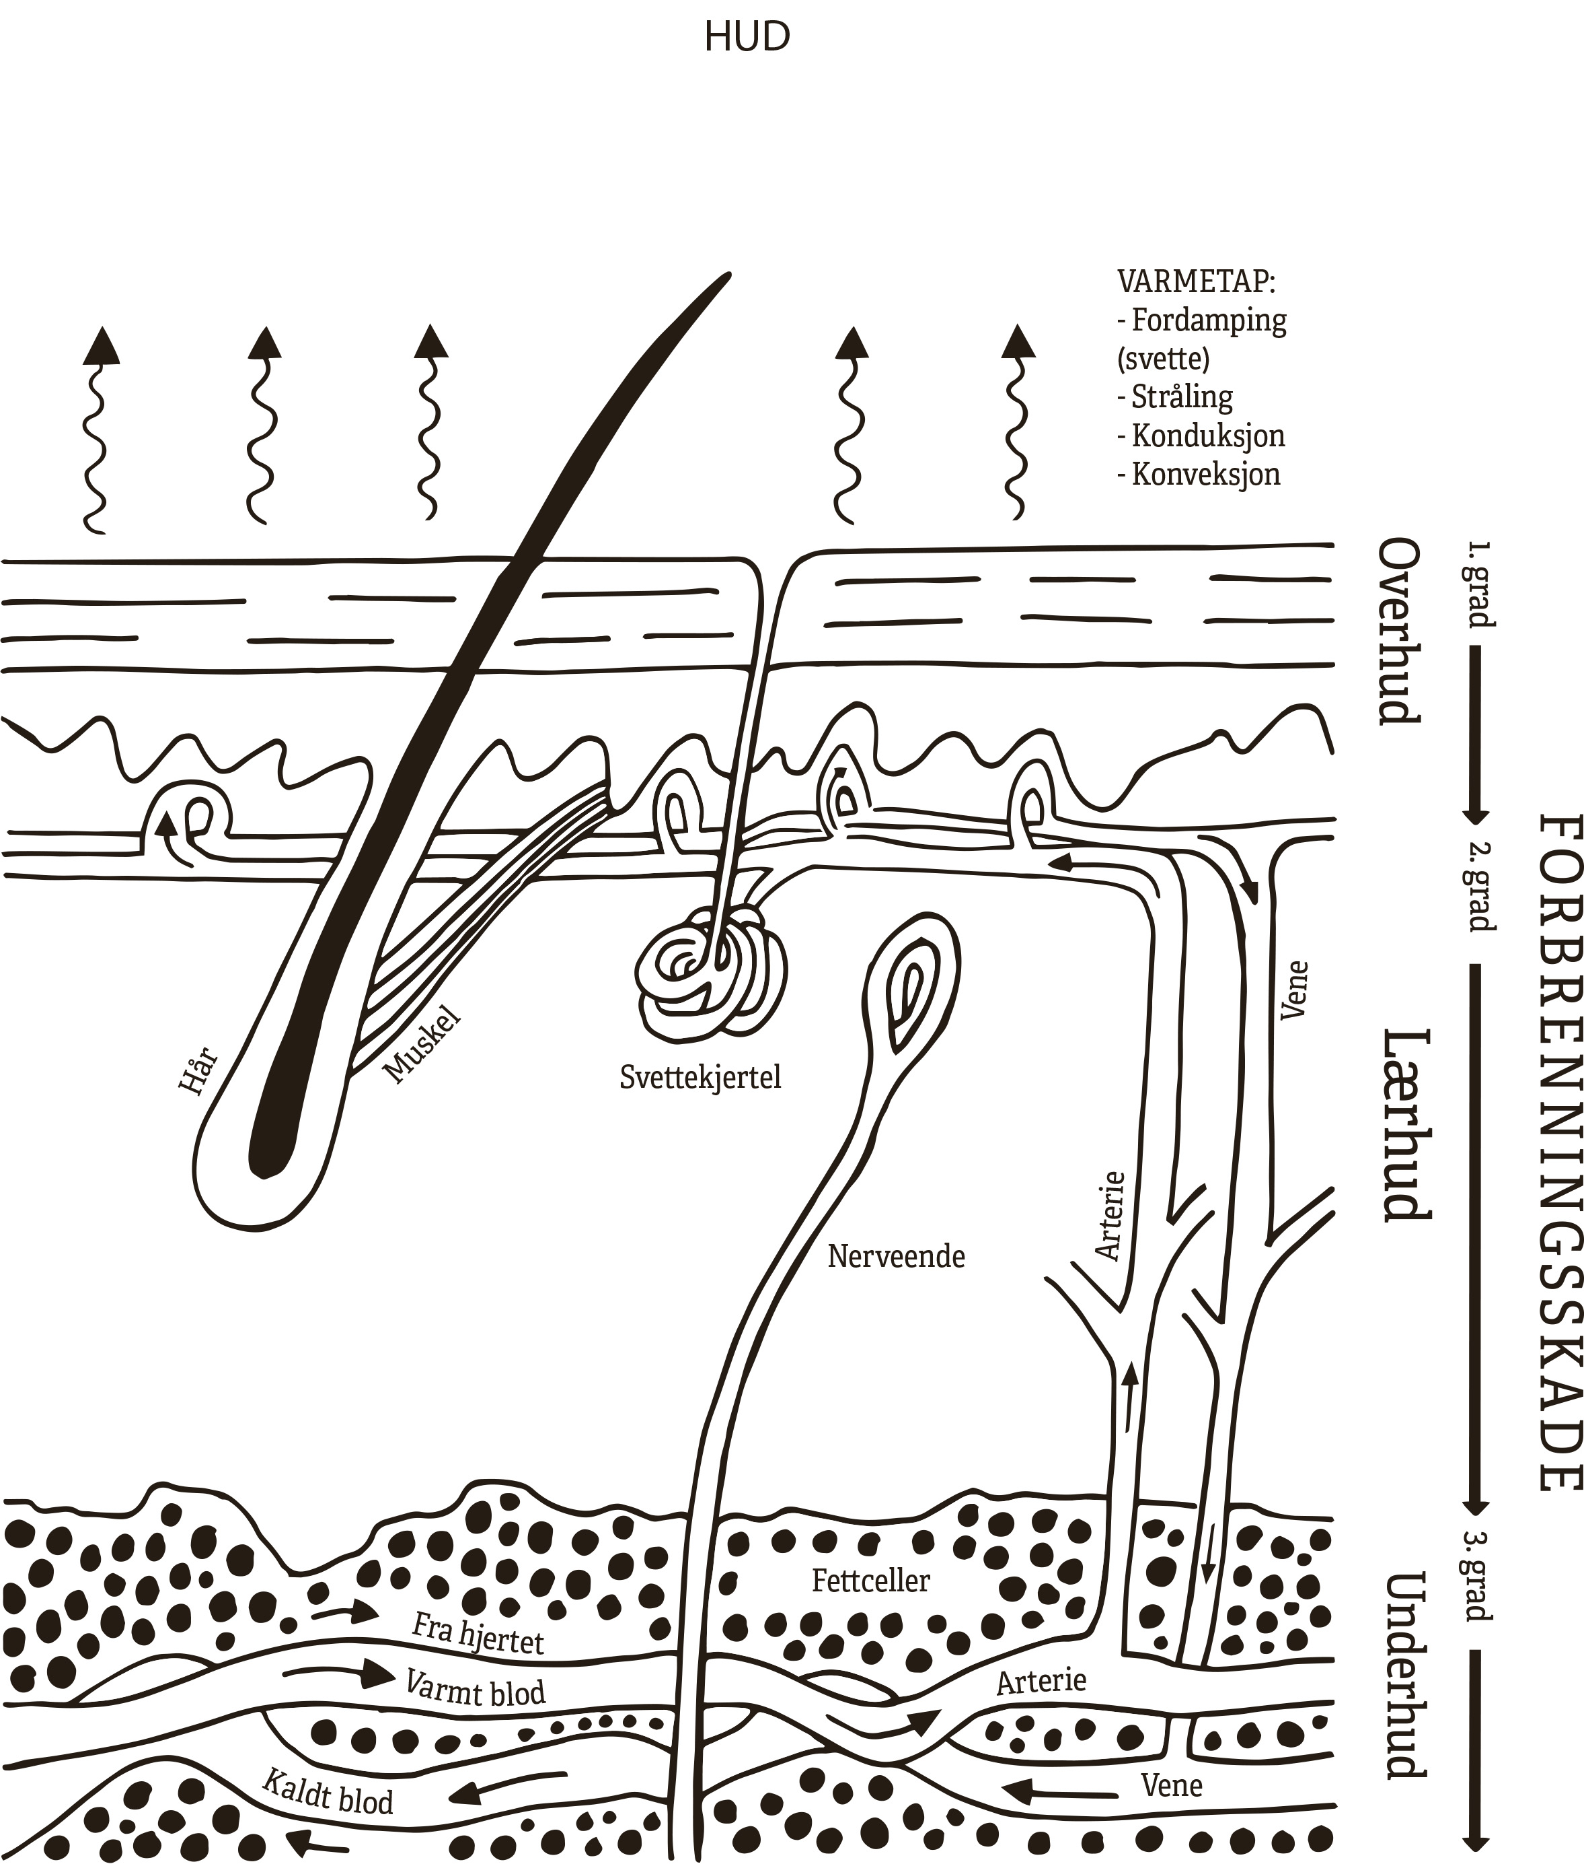

BURN INJURIES
Grade 1
Grade 2
Grade 3

Epidermis
Dermis
Subcutis

SKIN
HEAT LOSS

Evaporation (sweat)
Radiation
Conduction
Convection

Hair
Muscle
Sweat gland
Artery
Vein
Nerve end

Fat cells
From heart
Warm blood
Artery
Cold Blood
Vein

